**Ex. 3. Webpage Design using Html5 and CSS3**

**URK17CS127**

**Date:**

Create a webpage using proper HTML5 and CSS3.

1. **In header**
   1. Add website title. Align the text at center of the page. change font size and add text shadow effect.
   2. Make a simple rollover effect horizontal navigation bar using list of links. Removes the bullets of the link and remove the default text declaration from the links. This navigation bar should stretch the full width of the screen. The navigation elements themselves should still be centered over the content area.
2. **In section** 
   1. Add a **banner image** under the navigation bar. Display the dummy text over an image. (Hint: use margins and padding and use border-box as your box-sizing)
   2. Add three **thumbnails** below the banner, each of the 3 sections should take up equal amount of space on the screen. As you make the browser window wider or narrower, each section should become wider or narrower. Each thumbnail has a caption box that is positioned at the bottom. Set the background color to the boxes and the background color still allows the user to view the images.
3. Your page must include a CSS file. No inline styles allowed. Your CSS file should be placed into a “css” folder under the project folder,e.g Ex3/css.
4. All HTML pages must pass the official HTML5 specifications via <http://validator.w3.org/>
5. Publish your website live on web using any free web hosting services (000webhost)
6. Refer the mockup illustration of the site given in courses. Your final result should look very close to this mockup.

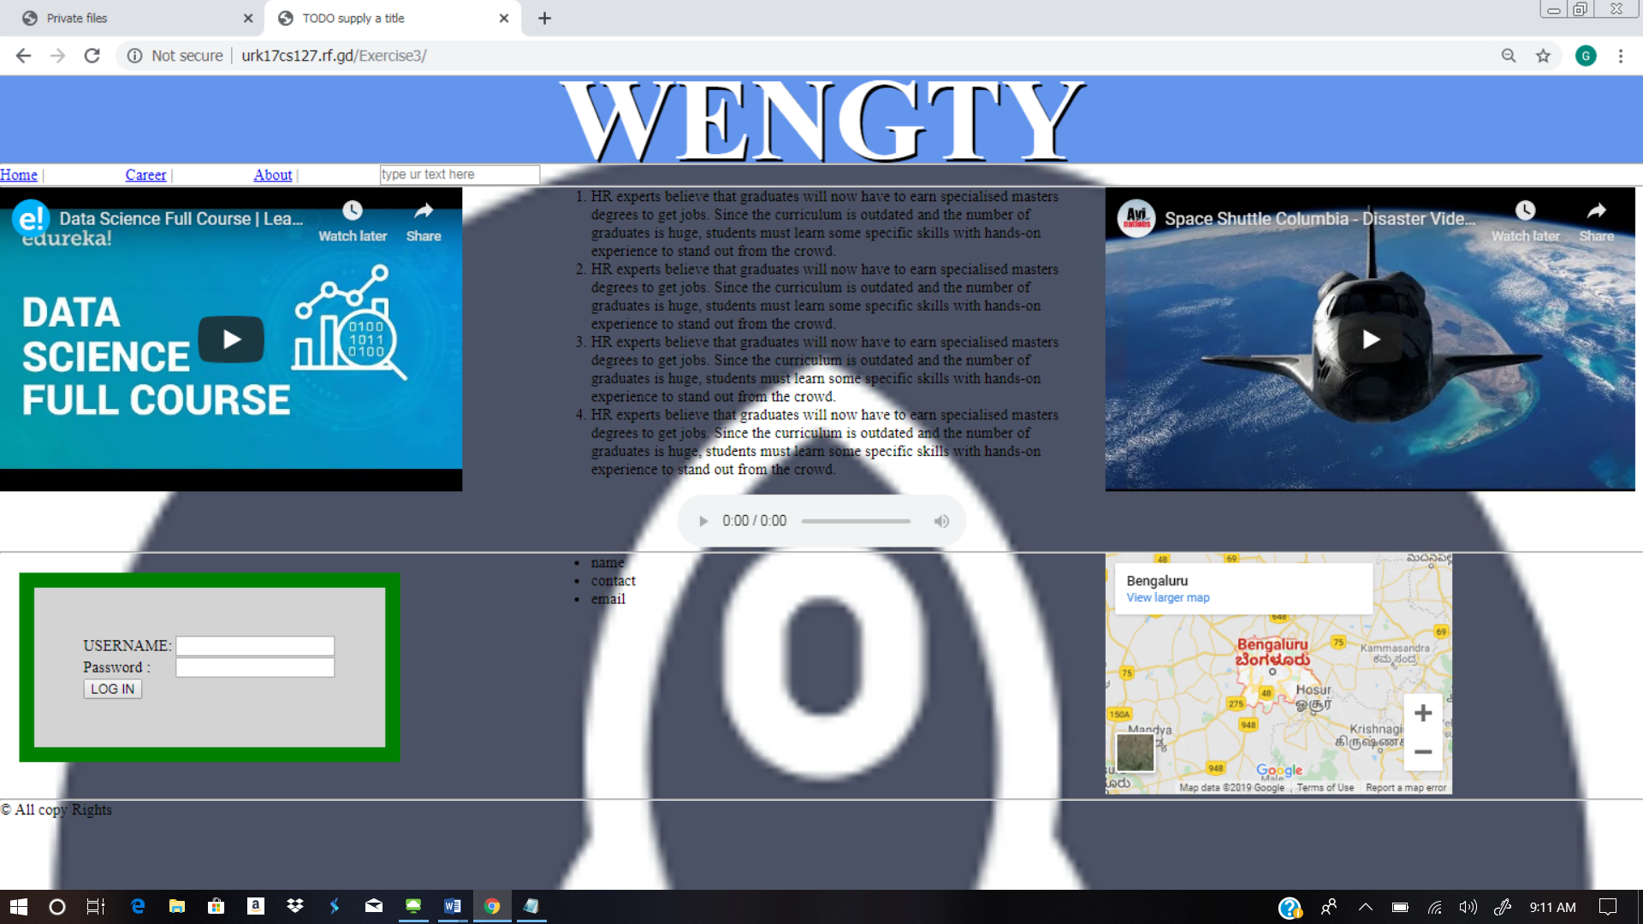

**Web site URL:** <http://urk17cs127.rf.gd/Exercise3/>

**You tube URL:** [**https://youtu.be/TXxXJToBzfk**](https://youtu.be/TXxXJToBzfk)